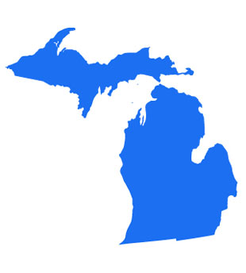

VOLUME 51 SPRING 2012 ISSUE 1

Fall Meeting
October 11-12-13th
2012



VOLUME 50 Fall 2011 ISSUE 2

President
Sieglinde Wildie MLT
25 Rural St.
Port Huron, MI 48060
H- 810-982-5651
W- 810-985-1525 Ext. 2438

Interim Vice President
Loretta Sweet MT
8165 Lakeshore
Lakeport, MI 48059
H-810-327-6847

Secretary
Nathalie Dixon MT
3358 Dale Road
Saginaw, MI 48603
H- 989-799-1664

Treasurer/Editor
Suellen Schobert MLT
1516 North Carolina
Saginaw, MI 48602
H- 989-793-6935

District Councillor
Clara Boykin MT
1023 Dayton Ave.
St. Paul, MN 55104
H- 651- 644-3128
W – 651- 647-2220

Board Members
Carol Cartwright RMA
982 M-68
Afton, MI 49705

Patricia Dare RMA
PO Box 120
Hamburg, MI 48139
H-810-231-0637

Webb Gray MT
27494 Mayfair Ave
Brownstown, MI 48183-4815
H-734-692-5902

Debra Herrst RMA
11600 Seitz Dr.
Dexter, MI 48130-9787
H-734-475-8857

Carolyn Spear, MT
939 Major Street
Flint, MI 48507-2364
H-810-234-0966

Nancy Winslow RMA
9491 Waite Dr.
Fenton, MI 48430

MSSAMT WEBPAGE
http://mssamt.tripod.com
MSSAMT EMAIL

MSSAMT@YAHOO.COM

Table of Contents:
Board Members | 1
Table of Contents | 2
President’s Message | 3
District Councillor’s  Message | 4
Editor’s Message | 5
Welcome  New Members | 6-9
Universal Precautions | 10-13
Fall Meeting Info. | 13
Member Anniversaries | 14
Congratulations | 14

American Medical Technologists
10700 West Higgins Road
Rosemont, IL 60018
800-275-1268/847-823-5169
Fax 847-823-0458
www.americanmedtech.org

MSSAMT MICROBE

Advertising Rates per Issue
Business Card $30.00
One Half Page $60.00
One Full Page $100.00
Money received for advertising will be used to help publish the MICROBE. Checks are to be written to MSSAMT. Information for publication should be submitted to the Editor.
PUBLICATION DATES:
FIRST ISSUE…….MAY/JUNE
SECOND ISSUE…NOV/DEC

The Microbe is a publication of the Michigan State Society of American Medical Technologists and is published two (2) times a year.

The views and opinions expressed herein are those of the contributors and do not necessarily reflect the opinions of the MSSAMT or American Medial Technologists. The Editor reserves the right to accept, reject or revise any material submitted for publication.


Make sure to send amt a change of address.

Do not get lost!

We cannot communicate if we do not know where you are

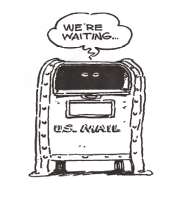
Please include your
Email address



President’s Message…

Hello My Fellow Members,

It seems we are all done with winter; and I hope everyone is enjoying the mild weather. In April at the last membership count, Michigan has 2897 members. Absolutely Great!

At the National convention in San Antonio, Texas, July 9-14, 2012, the state society will be represented by 11 delegates. We still have some delegate seats to be filled. If you wish to join us in San Antonio, Please call me at 1-810-982-5651. At the convention MSSAMT will receive two awards. One is the”State Honor Roll” and I am the recipient of the Silver Award. What an honor for me, to be chosen out of so many.

Thank You so Very Much.

I am already working on our fall scientific meeting, October 11-12-13, 2012 in Frankenmuth. I hope as many as possible will join us and taking advantage of listening to great lectures, enjoying the good food and friendly atmosphere. Earning your CEC’s at a very reasonable price is definitely a plus. It would be just wonderful if I could see you all at the fall meeting in Frankenmuth.

In the mean time, our board members will meet again in August with State Representative Mr. Paul Muxlow, to work on the state licensure bill for Medical Laboratory Personnel.

Until we meet at the October seminar, I wish every state society member and their families a “Glorious and Safe” summer.

Sincerely,
Sieglinde Wildie MLT

Great Lakes District
Councilor’s Message…

As members of the Great Lakes District of AMT, we are all looking forward to Spring and those of you with Spring Meetings are planning those at this time.

I just returned from a meeting with the AMT Board and Council in San Antonio, Texas, which is the location for our 74th Educational Program and National meeting this summer. July 9*- 14th, 2012, at the Hyatt regency San Antonio. 123 Losoya St., San Antonio, TX 78205. The room is $119.00 a night plus 17% tax. Make your plans now to attend. A great educational program is planned. Look for changes in the format of this meeting.

There is increased continuing education on the AMT web site. Camille Murray, the Educational Manager has made this available.

Kathy Cilia, Director of Marketing and Member Services, is in the process of redoing the promotional material for AMT. AMT also has a customer service department that is up and running.

Remember to continue to use AMTRAX. Keep copies of your information in the event it may be needed for verification of your entries.

April 22-28, 2012 is National Laboratory Professionals Week this year.

The 75th Educational Program and National Meeting will be held July 7-12, 2013 in Pittsburg, PA.

I continue to stress to all members. Please support your state society officers. If at all possible, show your support by attending your State Meetings.

If I can be of help, do not hesitate to contact me.

Clara Boykin, MT

1023 Dayton Avenue
St. Paul, Minnesota 55104
Email: claraboykin1023@msn.com
Work - 651 999 4788 (Monday thru Friday)
Cell - 651 247 3231 Home - 651 644 3128

 Editor’s Message ……

On April 28th the MSSAMT Board of Directors met in Frankenmuth at the Bavarian Inn for our Spring meeting. We covered many topics, such as the successful fall meeting we had last year and how we can better serve our members. I am sure that Siegi will have wonder speakers lined up as usual and you can not ask for a better location than Frankenmuth.

As Siegi mentioned in her message, we have 11 members signed up to attend the National Educational Meeting in San Antonio, Texas. That is the most delegates that I can remember attending in a long time. The meeting is always a wonderful time and several of our board members are on national committees and have input to the AMT organization. Next year the National Meeting will be in Pittsburg, PA, July 8 – 13, 2013. It will be the 75th national AMT meeting and I am sure it will be a very special event. Next year they will be consolidating some of the events and trying to make it more accessible to members. I will be posting more information later this summer.

The other big event to keep in mind will be the Great Lakes District meeting taking place next year. Many members form all the Great Lakes Sate Societies have been working hard on the planning. We will be having a special meeting in San Antonio this summer and there will be more information coming in the fall as to dates and location. Remember there will not be a Michigan state fall meeting in Frankenmuth next year, our state business meeting will take place at the district meeting.

I hope to see many of you in the fall, and please keep checking the website for more information that I will be posting this summer.

Suellen Schobert, MLT
MSSAMT Editor


MICHIGAN STATE SOCIETY
AMERICAN MEDICAL TECHNOLOGISTS

AHI |  |  |  |  | MLT
Amer | Alata |  |  |  | Leah |  |  | Provencal

MT
Ramon | Balde |  |  |  | Isaac |  |  | Karim
Lori | Newton |  |  |  | Priyanka |  |  | Patel

RDA
Frances | Goff |  |  |  | Jenny |  |  | Guerrero
Latichia | Watley

RPT
Regina | Beard |  |  |  | Francisco |  |  | Castillo
Kelsie | Cremeans |  |  |  | Denise |  |  | Dubisky
Pamela | Mattson |  |  |  | Monikia |  |  | Ratliff
Richard | Taylor |  |  |  | Gerald |  |  | Zielinski
CMAS
Colleena | Beard |  |  |  | Angela |  |  | Bliss
Joyce | Bowden |  |  |  | Stacy |  |  | Crafts
Kathy | Desgrange |  |  |  | Stacey |  |  | Hatfield
Patricia | Hughes |  |  |  | Sakinah |  |  | King
Jennifer | Luckie |  |  |  | Renee |  |  | Queen
Caroline | Rocha |  |  |  | Jessica |  |  | Star
LaShawn | Westbrook |  |  |  | Amanda |  |  | Williams
Patricia | Zanardi

RMA
Brenda | Sllrn |  |  |  | Shanon |  |  | Allen
Fleicia | Alverez |  |  |  | Samantha |  |  | Anderson
Laurisa | Andrade |  |  |  | Jeffery |  |  | Argue
Heather | Armstrong |  |  |  | Heather |  |  | Austin
Nichole | Austin |  |  |  | Shelby |  |  | Baker
Cherrelle | Bartley |  |  |  | Ann |  |  | Bartoszewicz
Sandra | Behlke |  |  |  | Diane |  |  | Belhabib
Jami | Bertke |  |  |  | Susan |  |  | Billmeier
Wayne | Bixler |  |  |  | Deanna |  |  | Blessing
Lisa | Bohr |  |  |  | Julia |  |  | Bolden
Layasha | Bonaparte |  |  |  | Stephanie |  |  | Bowker
Michelle | Bradacs |  |  |  | Holly |  |  | Bradley
Carolyn | Braggs |  |  |  | Kasandra |  |  | Brown
Duane | Brown |  |  |  | Jeanette |  |  | Brown
Jami | Bryan |  |  |  | Brenda |  |  | Buenrostro
Ericia | Buford |  |  |  | Anitra |  |  | Burnette
New Members Continued
RMA
Cynthia |  | Burns |  |  |  | Alyse | Burrows
Kristy |  | Busby |  |  |  | Jeffrey | Bussing
Linda |  | Byrd |  |  |  | Tara | Callahan
Francine |  | Carroll |  |  |  | Charissa | Carter
Elizabeth |  | Cassidy |  |  |  | Erika | Castro
Danielle |  | Chaffin |  |  |  | Cynthia | Chappell
Dilruba |  | Choudhury |  |  |  | Alisa | Clark
Felishia |  | Clark |  |  |  | Kanara | Clark
Pamela |  | Clark |  |  |  | William | Coffey
Linda |  | Cole |  |  |  | L’tanya | Cole
Stephanie |  | Coleman |  |  |  | Jamie | Combs
Ricky |  | Conard |  |  |  | Jennifer | Cook
Krista |  | Cook |  |  |  | Cynthia | Cornwell
Tukkata |  | Cothran |  |  |  | Jeffrey | Couthen
Shanton |  | Couthen |  |  |  | Meagan | Cos
Pamplette |  | Craine-Turley |  |  |  | Jennifer | Cramer
Traci |  | Crank |  |  |  | Penny | Cronkhite
Courtney |  | Cuffe |  |  |  | Olivia | Curl
Brianna |  | Curry |  |  |  | Adrien | Curry-Brown
Valerie |  | Curtis |  |  |  | Alice | Cutlip
Phyllis |  | Dahlstrom |  |  |  | Michelle R | Daley
Megan |  | Darland |  |  |  | Tommisheon | Davidson
Deana |  | Davis |  |  |  | Tina | Davis
Jessica |  | Deveraux |  |  |  | Tianna | Diaz
Tameron |  | Diehl |  |  |  | Kimberly | Doherty
Peyton |  | Doornhaag |  |  |  | Julie | Duesterberg
Shalonda |  | Duhart |  |  |  | Jacinda | Dumeney
Christina |  | Dungy |  |  |  | Allesa | Duvenary
Tiffany |  | Dymond |  |  |  | Amy | Eady
Laura |  | Elkins |  |  |  | Nicole | Elliott
Marla |  | Ennis |  |  |  | Samantha | Estep
Brittany |  | Fisher |  |  |  | Rachel | Frazier
Sharon |  | Fulton |  |  |  | Nikki R | Gasperini
Cristy |  | Gibson |  |  |  | Sandra | Goerner
Martha |  | Gogoll |  |  |  | Kasie | Gooslin
Andrea |  | Gotcher |  |  |  | Aubrey | Graves
Julie |  | Gray |  |  |  | Amanda | Gray
Teresa |  | Green |  |  |  | Jeffery | Gross
Bobbi |  | Hack |  |  |  | Shannon | Habermann
Teresa |  | Hagan |  |  |  | Amber | Hall
Rebecca |  | Hall |  |  |  | Kristi | Halliwill
Amber |  | Hammerie |  |  |  | Felicia | Hammonds
Nicole |  | Hansen |  |  |  | Rebecca | Harding
Michelle |  | Hardy |  |  |  | Tiffany | Harmon
Elvira |  | Harris |  |  |  | Moses | Harris
Moses |  | Harris |  |  |  | Amber | Harris
Heidi |  | Hatfield |  |  |  | Jennifer | Hayden
Margaux |  | Hazard |  |  |  | Ashley | Henderson
Sandra |  | Hendix |  |  |  | Teraesa | Herban
Amanda |  | Henandez |  |  |  | Tracy | Hiatt
Shekanah |  | Hill |  |  |  | Jodie | Hinman
Mary |  | Hodges |  |  |  | Michelle | Hoffman
Linda |  | Holter |  |  |  | Erica | Hood
Danielle |  | Houser |  |  |  | Sharon | Howard
Phillip |  | Hubbard |  |  |  | Megan | Hunt
Ebony |  | Jackson |  |  |  | Ericka | Jackson
Amanda |  | Jakubowski |  |  |  | Rebecca | Jarvis
Ebtesam |  | Jbara |  |  |  | Ricardo | Johnson
Sharese |  | Johnson |  |  |  | Alyssa | Jones
Lindsay |  | Jones |  |  |  | Linda | Jordan
Graciela |  | Jaurez |  |  |  | Jodie | Karrip
Martha |  | Keck |  |  |  | Allysia | Kester
Jamie |  | King |  |  |  | Kristy | Kirk
Melissa |  | Kohorst |  |  |  | Elaine | Koren
Terri |  | Krol |  |  |  | Vicki | Kropp
Jill |  | Krystyniak |  |  |  | Lynette | La Fleur
Sidney |  | La Fountain |  |  |  | Allyson | Laudensiager
Angela |  | Lawrence |  |  |  | Mistie | Lawrence
Michelle |  | LeFlore |  |  |  | Evelyn | LePain
Katrina |  | Lewis |  |  |  | Raymond | Linear
Mariah |  | Little |  |  |  | Nicole | Long
Nicole |  | Lopez-Singer |  |  |  | Breanna | Love
Holly |  | Lowe |  |  |  | Quiana | Lucas
Neil |  | Macvicar |  |  |  | Aprelle | Magee
Molly |  | Makino |  |  |  | Samantha | Martin
Sara |  | Maurer |  |  |  | Rene | Mayer
Cassandra |  | Mc Kinstry |  |  |  | Karen-Angel | Mc Pherson
Shoshawna |  | McPhail |  |  |  | Dylan | Meade
Crystal |  | Meadows |  |  |  | Patricia | Melcher
Jamie |  | Mesic |  |  |  | Rochelle | Miller
Tyeisha |  | Mitchell |  |  |  | Brittany | Mitchell
Elizabeth |  | Monahan |  |  |  | Chasity | Moore
Megan |  | Moore |  |  |  | Bethany | Moralez
Joanna |  | Morris |  |  |  | Latashia | Moss
Christy |  | Murphy |  |  |  | Hilery | Murray
Lisa |  | Myers |  |  |  | Rana | Nahass
Rachel |  | Newton |  |  |  | Anita | Nielands
Kacey |  | Nieman |  |  |  | Norah | Noble
Jessica |  | Ochieng |  |  |  | Tammy | O’Dell
Jerica |  | Olney |  |  |  | Renee | Pankey
Karen |  | Paradise |  |  |  | Denita | Pastucha
Denise |  | Perrine |  |  |  | Kristin | Peterson
Nicole |  | Pickard |  |  |  | Tammy | Pikarski
Pamela |  | Pingilley |  |  |  | Sabrina | Polk
Leishia |  | Polo |  |  |  | Nicole | Polzin
Enereida |  | Posada |  |  |  | Ashley | Poulin
Nicole |  | Powers |  |  |  | Timolin | Pozon
Rosemary |  | Presnell |  |  |  | Stephanie | Puffer
Lorie |  | Raab |  |  |  | Christina | Raupp
Lori |  | Reed |  |  |  | Marcia | Robbins
Meagan |  | Romano |  |  |  | Rhonda | Romanowski
William |  | Rose |  |  |  | Cassandra | Rowe
Jacqualyn |  | Rust |  |  |  | Irene | Salas
Elmedina |  | Salkic |  |  |  | Danielle | Schillman
Christopher |  | Schobert |  |  |  | Ashley | Schoetzow
Cynthia |  | Schultz |  |  |  | Sharon | Schultz
Laura |  | Schott |  |  |  | Rachel | Shackleford
Stephanie |  | Shepherd |  |  |  | TeArrace | Sherman
Michelle |  | Sibinovski |  |  |  | Angela | Sienkowski
Rebekah |  | Slabinski |  |  |  | Teresa | Slezinski
Aaron |  | Smith |  |  |  | Amanda | Smith
Deborah |  | Smith |  |  |  | Dustin | Smith
Jeri |  | Smith |  |  |  | Lisa | Smith
Millisa |  | Smith |  |  |  | Shayna | Smith
Maria |  | Solis |  |  |  | Amanda | Sorenson
Sonja |  | Sorenson |  |  |  | Megan | Southwell
Joannah |  | Spurr |  |  |  | Crystal | Stamper
Seema |  | Stanton |  |  |  | Vaness | Stermer
Daysia |  | Serner |  |  |  | Jaimie | Stockton
Samantha |  | Stoddard |  |  |  | Judea | Stokes
Joshua |  | Stringham |  |  |  | Lacey | Stringham
Brendalee |  | Styber |  |  |  | Beth | Sweet
Stacey |  | Taylor |  |  |  | Christina | TenBrink
Margaret |  | Thatcher |  |  |  | Elizabeth | Thelen
Lakeisha |  | Thomas |  |  |  | Michael | Thomas
Qajavanique |  | Thompson |  |  |  | Debra | Thurston
Andria |  | Tipton |  |  |  | Brittany | Tisdale
Beverly |  | Turner |  |  |  | Kayla | Vanassche
Elena |  | Veliz |  |  |  | Rachel | Vella
Holly |  | Venier |  |  |  | Ashley | Vereecke
Jamie |  | Verstraete |  |  |  | Pamela | Vos
Mandy |  | Waite |  |  |  | Jack | Walburn
Julie |  | Walker |  |  |  | Porsha | Walton
Tammie |  | Ward |  |  |  | Rebekah | Warne
Marcella |  | Webster |  |  |  | Jessica | Weiss
Lori |  | Wenzel |  |  |  | Amanda | White
Sandra |  | White |  |  |  | Tammy | White
Angela |  | Wiggins |  |  |  | Rovonya | Williams
Cheryl |  | Willis |  |  |  | Lauren | Wilson
Nicole |  | Windle |  |  |  | Cheryl | Wines
Heather |  | Woodard |  |  |  | Noreen | Woodside
Irene |  | Yearry |  |  |  | Lauren | Zwyghuizen

Keep track of those CEC’s by entering data online using AMTrax.
Log in to www.americanmedtech.org and click on AMTrax under the CE tab.

We employ the use of Standard Precautions every day in our work places but perhaps we have not reviewed the practices for some time. We do not have room to cover all areas but will list the most commonly used standards.

Assume that every person is potentially infected or colonized with an organism that count be transmitted in the healthcare setting and apply the following infection control practices during the delivery of health care.

Hand Hygiene

- During the delivery of healthcare, avoid unnecessary toughing of surfaces in close proximity to the patient to prevent both contamination of clean hands from environmental surfaces and transmission of pathogens from contaminated hands to surfaces.

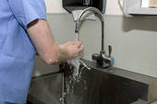
- When hands are visibly dirty, contaminated with proteinaceous material, or visibly soiled with blood or body fluids, wash hands with either a nonantimicrobial soap and water or an antimicrobial soap and water.

- If hands are not visibly soiled or after removing visible material with nonantimicrobial soap and water, decontaminate hands. The preferred method of hand decontamination is with an alcohol-based hand rub.

- Alternatively, hands may be washed with an antimicrobial soap and water. Frequent use of alcohol-based hand rub immediately following hand washing may increase the frequency of dermatitis.

Perform hand hygiene:
Before having direct contact with patients.

After contact with blood, body fluids or excretions, mucous membranes, nonintact skin, or wound dressings.

After contact with a patient’s intact skin (e.g., when taking a pulse or blood pressure or lifting a patient)

If hands will be moving from a contaminated–body site to a clean-body site during patient care.

After contact with inanimate objects (including medical equipment) in the immediate vicinity of the patient.

After removing gloves.

Do not wear artificial fingernails or extenders if duties include direct contact with patients at high risk for infection and associated adverse outcomes.

Personal Protective Equipment (PPE)


Wear PPE when the nature of the anticipated patient interaction indicates that contact with blood or body fluids may occur.

Prevent contamination of clothing and skin during the process of removing PPE.

Before leaving the patient’s room or cubicle, remove and discard PPE.

Gloves
Wear gloves when it can be reasonably anticipated that contact with blood or other potentially infectious material, mucous membranes, nonintact skin or potentially contaminated intact skin could occur.

Wear gloves with fit and durability appropriate to the task.

Wear disposable medial examination gloves for providing direct patient care.

Wear disposable medical examination gloves or reusable utility gloves for cleaning the environment or medical equipment.

Remove gloves after contact with a patient and/or the surrounding environment using proper technique to prevent hand contamination.

Do not wear the same pair of gloves for the care of more than one patient. Do not wash gloves for the purpose of reuse since this practice has been associated with transmission of pathogens.

Change gloves during patient care if the hands move from a contaminated body site to a clean body site.

Gowns
Wear a gown, that is appropriate to the task, to protect skin and prevent soiling or contamination of clothing during procedures and patient-care activities when contact with blood, body fluids, secretions, or excretions is anticipated.

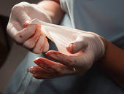
Wear a gown for direct patient contact if the patient has uncontained secretions or excretions.

Remove gown and perform hand hygiene before leaving the patient’s environment.

Do not reuse gowns, even for repeated contacts with the same patient.

Mouth, nose, eye protection

Use PPE to protect the mucous membranes of the eyes, nose and mouth during procedures and patient-care activities that are likely to generate splashes or sprays of blood, body fluids, secretions and excretions. Select masks, goggles, face shields, and combinations of each according to the need anticipated by the task performed.



SAFE WORK PRACTICES
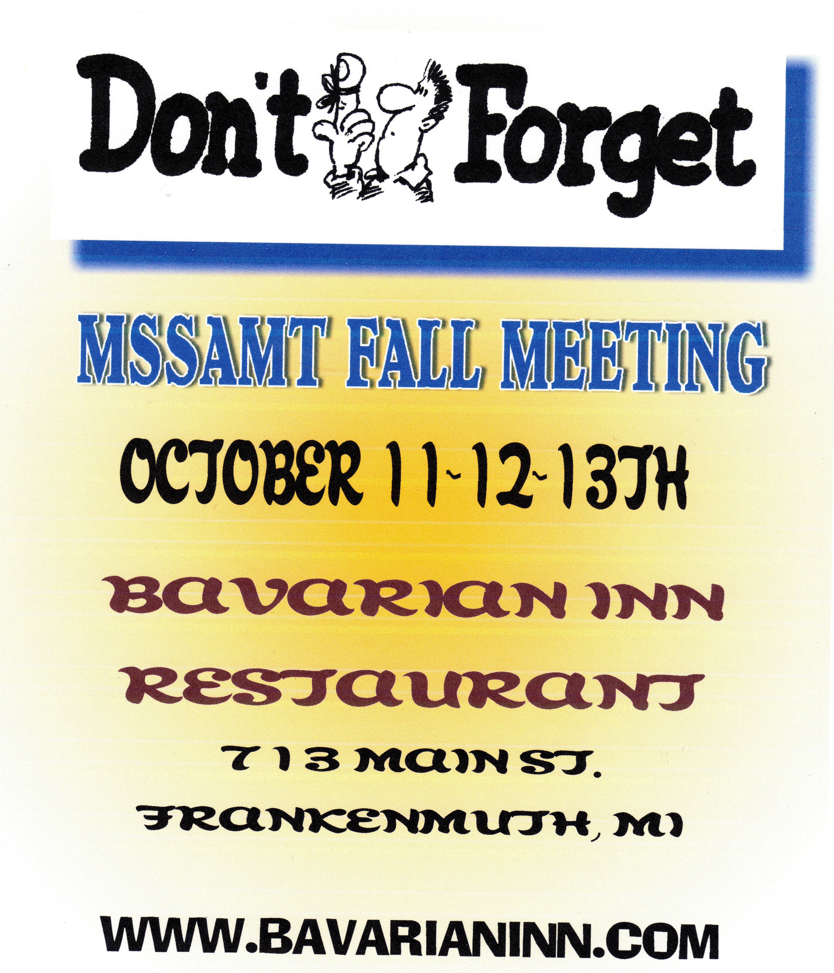
- Keep hands away from face
- Work from clean to dirty
- Limit surfaces touched
- Change PPE when torn or heavily contaminated
- Perform hand hygiene

References; 2007 Guideline for Isolation precautions: Preventing Transmission of Infectious agents in Healthcare Settings

Jane D. Siegel MD; Emily Rhinehart, RN MPH CIC; Marguerite Jackson, PhD; Linda Chiarello, RN MS; The Healthcare Infection Control Practices Advisory Committee

Center for Disease Control [CDC} 1600 Clifton Rd. Atlanta, GA 3033
CDC Guideline for Hand Hygiene in Health-Care Setting

Upcoming Events:-

AMT Educational Program and National Meeting:

San Antonio, Texas - Hyatt Regency July 9 – 14, 2012

Pittsburg, PA – Station Square July 8 – 13, 2013

MSSAMT Fall Scientific Meeting – October 10th, 11th and 12th, 2012
Bavarian Inn Restaurant
Frankenmuth, MI

PRESORTED STANDARD
U.S. POSTAGE

PAID
SAGINAW, MI 48602
PERMIT NO. 248
MSSAMT MICROBE
Suellen L. Schobert MLT
1516 North Carolina
Saginaw, MI 48602-3910

